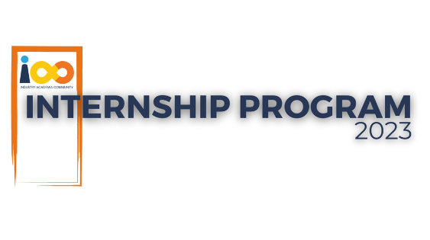

**PROJECT CHARTER**

|  |  |
| --- | --- |
| **GENERAL PROJECT INFORMATION** | |
| PROJECT NAME | CodeCruise CI/CD pipeline solution |
| PROJECT SPONSOR | Tushar Topale |
| PROJECT MANAGER | Harshada Topale |
| EXPECTED START DATE | 20-02-2024 |
| EXPECTED COMPLETION DATE | 10-05-2024 |
| ESTIMATED COST | NA |
| **GOALS, OBJECTIVES, DELIVERABLES** | |
| PROJECT OBJECTIVE | The objective is to build a unified CI/CD Pipeline that is linked to company website and jenkins using cloud archicture where it is easy to Cloud Counslage tech people to develop and maintain the application easily using the CI/CD solution and also monitor/test the security aspects while deploying easily and well manageable way. |
| BUSINESS CASE | To help Developers/operations people to easily deploy and maintain the application using CI/CD Solution. |
| GOALS/METRICS | The main aim is to create a Industry standard and promising CI/CD Development pipeline to deply easily and maintain proper codebase. |
| EXPECTED DELIVERABLES | A fully functional CI/CD demo video in mp4 format , code in zip format with github link and project documentation with detailed howto's. |
| **PROJECT SCOPE AND SCHEDULE** | |
| WITHIN SCOPE | A functional MVP (Minimum viable product) CI/CD pipeline connected with GCP Cloud/AWS using open source softwares/services like jenkins , sonarqube, OWASp Dependency Scanner and docker. |
| OUTSIDE OF SCOPE | it is not possible to keep the servers active 24/7 in active state as it is my free trial account, so it is for purely for development purpose. |
| **PROJECT RESOURCES AND COSTS** | |
| PROJECT TEAM | Subodh Kamble |
| SUPPORTED RESOURCES | GCP/AWS Cloud , Docker, jenkins , sonarqube, nginx , OWASP dependency scanner, VS Code, HTML/CSS/JS |
| COST ALLOCATION | NA |
| **PROJECT STAKEHOLDERS AND CUSTOMERS** | |
| PROCESS OWNER | Harshada Topale |
| KEY STAKEHOLDERS | Harshada Topale |
| END CUSTOMERS | Cloud Counselage Pvt. Ltd. |
| **PROJECT RISKS, CONSTRAINTS, ASSUMPTIONS** | |
| RISKS | it will be not fully production ready CI/CD pipeline and more technical expertise will be needed to make it production ready. |
| CONSTRAINTS | Cannot use paid services and propriatory software to develop |
| ASSUMPTIONS | Some bugs will be still there and more technical people should get involve before deploying to production |
| **MILESTONES** | |
| MILESTONE 1-REQUIREMENT GATHERING | 20/02/2024 |
| MILESTONE 2-PLANNING | 01/03/2024 |
| MILESTONE 3-DESIGN | 15/03/2024 |
| MILESTONE 4-DEVELOPMENT | 20/03/2024 |
| MILESTONE 5-TESTING | 20/04/2024 |
| MILESTONE 6-DEPLOYMENT | 01/05/2024 |
| MILESTONE 7-CLOSURE | 10/05/2024 |